Week: 14
Experiment: 13
“To determine Blood group using the Anti-A, Anti-B, and Anti-D reagents.”

Total Marks (30 Marks):
1) Lab Performance (10 Marks):
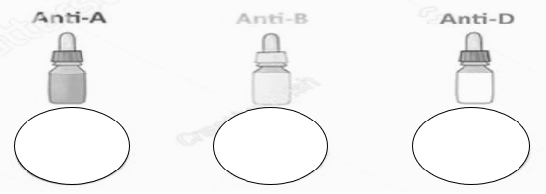
2) Observation (5 Marks):

- Anti-A Serum: Dark Blue
- Anti-B Serum: Yellow
- Anti-D (Rh) Serum: More like Translucent solution

3) Picture (2 marks):
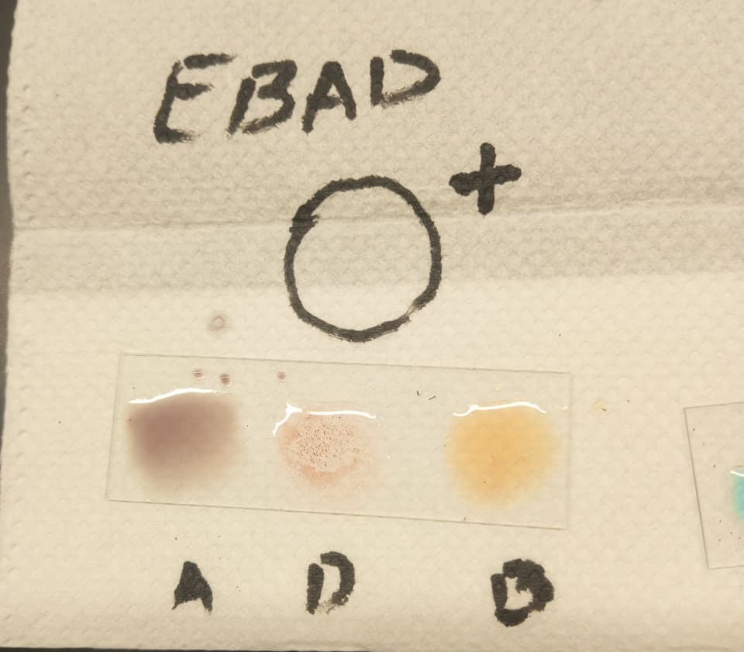
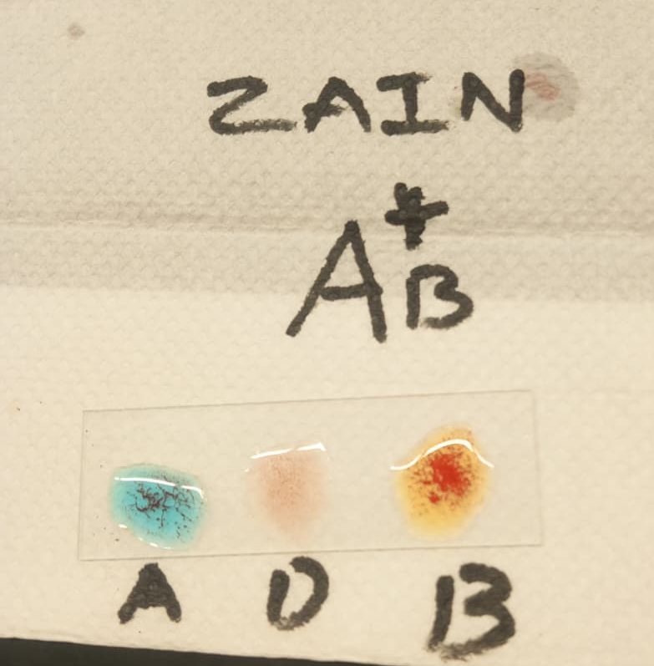

4) Result (3 Marks):

ZAIN's Results (Image 1):
- A: Agglutination (clumping) - blue/dark reaction
- D: Agglutination
- B: Agglutination – clumping
Blood Type: AB positive (AB+)

EBAD's Results (Image 2):
- A: No clumping- brown/dark reaction
- D: Agglutination - clumping
- B: No clumping - clear/yellow
Blood Type: A positive (O+)

5) Labster Simulation (10 Marks):

6) Problems:
Initially we didn’t mix it blood anti gens properly, so got wrong results.

